Volunteer Advisory Panel member – Application Pack
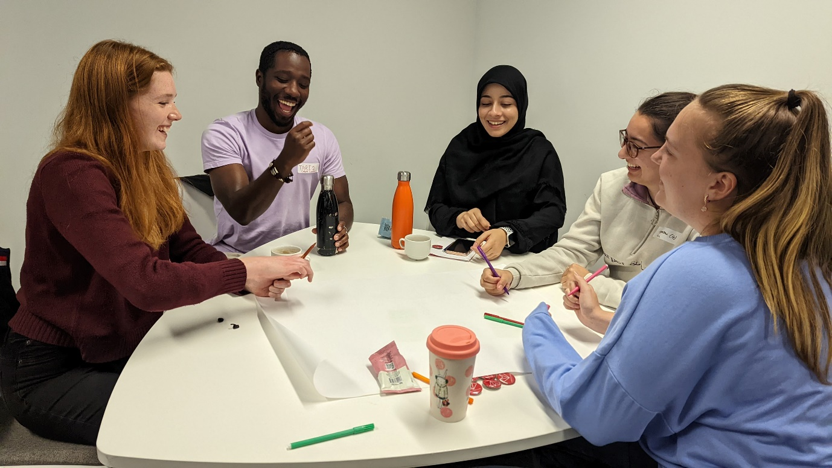
About the Volunteer Advisory Panel
The Volunteer Advisory Panel will have strategic oversight of the organisation and play a key role in strategic decision making – what projects should StreetDoctors focus on? How should we best engage and motivate our volunteers? How can StreetDoctors best meet the needs of young people affected by violence? It will sit alongside the Board of Trustees (but without any legal responsibility).
The Volunteer Advisory Panel will work with the central team, volunteers and Trustees on new ideas, volunteer management, developments in StreetDoctors and strategy for the organisation. Members will be able to contribute their ideas, collate views from volunteers in their area and give feedback on the direction of StreetDoctors.
About the role
The Volunteer Advisory Panel gives a really exciting and new way to be part of the StreetDoctors movement, and ensure we are listening to our volunteers as we develop the best ways to support young people affected by violence.
Role | StreetDoctors Volunteer Advisory Panel Member
Commitment | 2 years in post, with a minimum of 50% attendance to all meetings and activities.  4 meetings a year, most likely online.
Reporting to | Frances Breeveld, Communications and Policy Officer
Pay | Voluntary role. Expenses such as travel and food when attending meetings or events will be covered.

What the role will involve:
- Attending and actively participating in quarterly Volunteer Advisory Panel meetings. These will be held on the second Thursday of January, April, July and October.
- Reading any updates and information presented before meetings to be fully prepared to participate in discussions.
- Attending any socials and strategy days where possible.
- Acting as a representative for volunteers in your region - collating what volunteers think on certain topics or ideas and voicing their opinions.
- Acting as ambassadors for StreetDoctors externally, for instance, by taking part in media appearances or speaking at conferences.
Benefits for panel members:
- Great personal and professional opportunity to be part of an Advisory Panel for a national organisation; a national leadership role at a leading healthcare charity.
- You will be accredited for your time and involvement in the panel with a certificate, and references provided where needed.
- Access to training for your own development and to help fill your role on the panel, for instance public speaking, media training, meeting facilitation or creating budgets.
- Opportunities to attend staff team meetings and trustee meetings by invitation, also opportunities to attend relevant conferences and talks in the youth and reducing violence sector.
- Opportunity to explore leadership positions within the youth and healthcare charity sector.
Who we are looking for
If you are committed to reducing street violence, passionate about StreetDoctors work and would love to develop your leadership skills, then we would love to hear from you!
Members
The panel will have 16 members in total by 2024, spread across 4 regions of the UK to ensure equal team representation. We are recruiting 8 members per year, so this year we are recruiting 2 members per region, set out below:
Region | Northwest | Northeast | Southeast | West and Midlands
Teams | Belfast  Glasgow  Keele  Liverpool  Manchester  Preston | Hull  Leeds  Newcastle  Nottingham  Sheffield | London teams  Southampton | Birmingham  Bristol  Cardiff  Leicester  Warwick

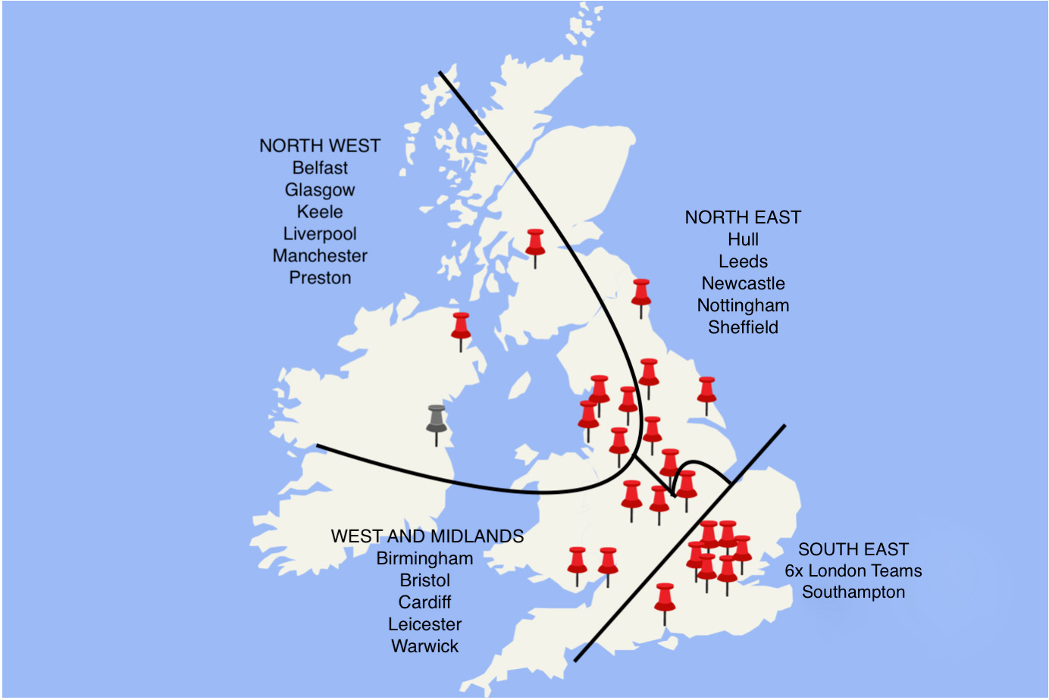
Requirements
- Became a StreetDoctors volunteer in 2021 or earlier
- Have experience of delivering StreetDoctors training sessions to young people
- Have been involved in StreetDoctors (e.g. team meetings, volunteer training or session delivery)within the past 2 years
Person Specification
Essential
- Experience of strategic thinking about a project or organisation
- Friendly and approachable
- Reliable, punctual and trustworthy
- Good listener
- Excellent written and verbal communication skills
- Ability to work in a team and have collaborative discussions
- Keen interest in StreetDoctors and being part of the solution to reducing violence affecting young people
Desirable
- Experience of a committee or council (paid or voluntary)
- Experience of planning budgets
- Experience of public speaking or speaking to media

How to apply
- Complete application form questions below and send the form and your CV (no longer than 2 pages) to frances@streetdoctors.org.
- Ask someone from your team to complete the Team Reference form here.
Deadline for application form, CV and reference is Midnight on Wednesday 7th December 2022
Short interviews will be held virtually w/c 12th December. If you have any questions about the role or the application process, please email frances@streetdoctors.org.
---------------------------------
Volunteer Advisory Panel Member – Application form
- Name
- Your StreetDoctors team
- History of your roles in StreetDoctors. Detail when you joined and if you have undertaken any specialist or team leader roles and which years these were. E.g. Joined 2019, Communications Specialist 2020-2021, Team Leader 2021-2022

- Why do you want to be part of the Volunteer Advisory Panel? (max. 250 words)

- What skills and experiences can you bring to the panel? Give examples of paid, student or voluntary roles that are listed in the essential or desirable person specification (max. 250 words)

- Can you commit to the role for 2 years (January 2022 – January 2024)?
Yes / No / Unsure

- The first meeting will be 12th January 2023 at 7pm, online. Please confirm if you are able to attend this?
Yes / No / Unsure

- To apply for this role your team, or someone on your team, will have to give a short reference. It will have to be completed by Wednesday 7th December. The reference form is here.
Name of the person who will be completing the reference by the deadline:
_____________________________________________________

- Do you need any adjustments made to attend the online interviews or attending the online quarterly meetings?
Yes / No
If yes, please give details: _____________________

